Advanced Healthcare Directive App

**Student:** Dean Devereaux

**ID Number:** R00116198

**Course:** Electronic Engineering

**Module:** Tech Enterprise

**Lecture:** Finbarr Sheehan

# Background:

An advanced healthcare directive is a medical form in which an individual chooses which medical treatment they wouldn’t like to receive or would like to receive if at all needed. This form would come into effect when the individual can’t communicate to medical professionals due to an illness or loss of consciousness. This form allows for doctors to work on patients based on their best wishes and doesn’t cause family members to make the decision for them.

# Idea:

The AHCD App would allow this form to be saved digitally and would not be a problem to find in emergency situations. An individual would have to sign into the app to create their user so then they may write or even record their best wishes through the app. For healthcare workers they will then be able to find a patient through their phone. Similar to the way in which an iPhone allows users to create a medical ID and show their details this app will do the same allowing medical professionals to view an individual’s best wishes through their lock screen. An alternative way to view an individual’s details is through the app on another device were it can be found through the use of their name, PPSN and address.

# Similar Apps

On the Play Store and App Store three apps where found which allowed the user to create an advanced healthcare directive.

For both android and iPhone “My Health Care Wishes” was present on both stores. This app is the only one that has a price but also seems to have more features such as allowing a library for the advanced health care directive and the ability to send a PDF version through email to family members and healthcare assistants. This app doesn’t save the data of users onto a server but instead keeps the info within your phone

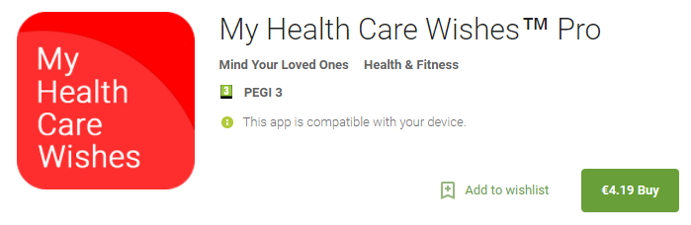

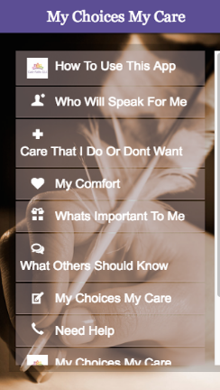

“My Choices My Care” is a free app on the play store which gives advice through links to YouTube videos about what the advanced health care directive gives before the user creates it. Not much is said about the app on the play store but from using it can be seen that the form must be submitted therefore it is unsure if this is saved onto the phone or send to the data base of the company who created the app.

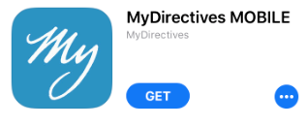“MyDirectives” was found on the App Store and is a mobile version of a website advanced healthcare directive submission. This version of an advanced healthcare directive allows the user to create a video, audio and even written form however hospitals must go onto the “MyDirective” app in order to find your details.

# Potential size of market

This app is for individuals who want to save their best wishes when it comes to medical procedures they would like to be performed on them when they are unconscious and can’t communicate for themselves therefore it applies to everyone worldwide however countries have their own legal status of what an individual can and can’t have on their advanced healthcare directive form and for what reasons they would use the form.

This App would be started within Ireland as a trial on the Play Store and App Store to see how beneficial and productive it would be to society and medical employees. If this app gets a positive response then it would have a chance in Europe and even worldwide as long as there are not international versions of this app already created for individual countries in the future.

# Articulate how your app differs from others on the market

The app proposed will be different to the similar apps discussed above as it can be used in emergency situations with the feature of being accessible through the lock screen of an individual’s phone. The advanced health care directive will be saved on both the mobile device and online to ensure that the form can be accessed quickly. Being able to acquire the advanced healthcare directive online would be useful in situations where the individual’s phone is not reachable.

# What problem does it solve or what benefit is gained

With the proposed app healthcare workers have the opportunity to see if a certain patient has an advanced health care directive without the need to contact a family member. This app would be beneficial in emergency situations were a doctor or first responder has to act fast and so finding this persons details on an app form would allow for fast action. The advanced healthcare directive itself has its own benefits but in app form this would allow for easy access.

Another benefit with this app again would come into emergency situations when a medical professional has to act fast. The medical professional could perform a procedure in which the individual wished against due to the advanced healthcare directive not being available. Allowing the advanced healthcare directive to be in app form allows the medical professional to know their patients wishes and act in accordance to this form.

# Unique selling proposition

Firstly this app is to be used for medical purposes therefore this will be promoted to show society how beneficial it is to have an advanced health care directive for their health in unfortunate circumstances. This app will allow medical professionals to find a person’s details without going passed the lock screen of their phone allowing security with their phone and easy access to their best wishes. This app would be made free as people deserve to have the choices to write this form and have it saved digitally without a cost.

# Reference

<https://hospicefoundation.ie/programmes/advance-care/questions-and-answers-on-advance-healthcare-directives/>

<https://www.americanbar.org/publications/youraba/2014/may-2014/advance-health-care-directives--theres-an-app-for-that.html>

<https://play.google.com/store/apps/details?id=com.mindyourelders.MyHealthCareWishes.HomeActivity>

<https://play.google.com/store/apps/details?id=com.app.appec267860f713>

<https://www.mydirectives.com/>